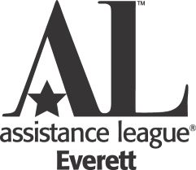 **Operation School Bell® - Service Request Form 2022-2023**

**Operation School Bell provides clothing to students who demonstrate financial**

**need and attend schools in Snohomish County. Your child’s school will**

**arrange for your child to receive new school clothes. This completed form**

**must be returned to your child’s school. We look forward to serving your child.**

**___________________________________________________________________**

**Everett School District** Date __________________________



**School Personnel: *Please complete the top section of this form.***

**Student Name** _____________________­­­­­­­­­­­­­­­­­­­­­­­­­­________________________________________________________

Please Print First Name Last Name

**Student I.D. Number _______________________________ Gender __________Male __________Female**

**School Name ____________________________________________ Grade _________________________**

**School Representative Name** ________________________________ **Phone** _________________________ **___________________________________________________________________**

**Parent/Guardian:** ***Please complete this section of the form and return to your child’s school.***

**Student Name**_____________________________________________________________________________

Please Print First Name Last Name

I give permission for my child to be served by Operation School Bell.

Please check one: ____ **I give** ____**I do not give** Assistance League of Everett permission to publish in print, electronic or video format, the likeness or image of my child for publicity purposes solely for the benefit of Assistance League and waive any right of compensation or copyright ownership thereto. This photo permission does not affect your child’s ability to receive clothing.

**Parent/Guardian Signature** ______________________________________

**Print Name** ____________________________________________________

**Please complete the attached Operation School Bell Order Form 2022-23.**

***We encourage you to size up if you are in doubt about the correct size. Clothing cannot be returned***.